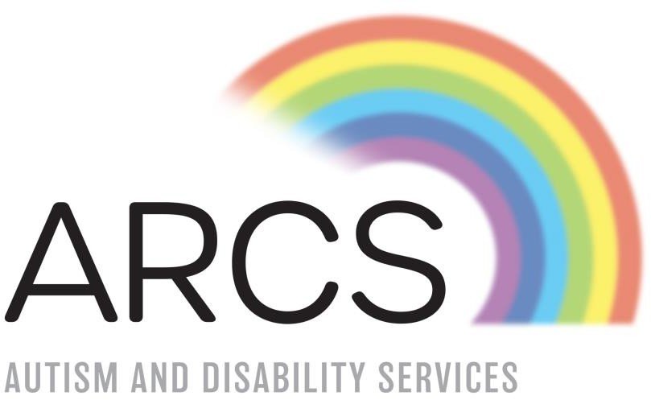

REFERRAL FORM
ARCS
AUTISM AND DISABILITY SERVICE

TABLE OF CONTENTS

Referral and Admissions Procedure 2
Admissions to the Designated Centre: 2
Criteria used for determining admission: 2
Specific Criteria for Admission applicable to people with specific support needs 2
Admission Documentation 3
Pre-admission: 3
Policy for emergency admissions: 4
Referral Form 5
Pre-Admission Collective risk Assessment 8
Vulnerabilities Risk Assessment 10
Developmental Needs/ Supports/ Health 12
Medical Needs 12
Physical Needs and Development 13

REFERRAL AND ADMISSIONS PROCEDURE

Admissions to the Designated Centre:

Registered Bed Numbers: | Our Residential Services will provide for a maximum of 3 / 4 residents at any one time.
Age range of residents to be accommodated: | Or Residential will provide for residents aged 18 or younger
Gender of residents to be accommodated: | Our Residential Services will provide inclusively for all genders.

Criteria used for determining admission:
The following general criteria must be met in order to secure admission to ARCS Full-time / Shared Care services:
- The applicant must be a person with a diagnosis of ASD, Intellectual Disability or other Pervasive Developmental Disorder
- A suitable vacancy must be available in the service requested;
- The Admissions Committee must agree that the needs of the applicant can be met in the service requested;
- The necessary resources as may be reasonably necessary to meet any additional disabilities and/or complex needs must be in place.

Specific Criteria for Admission applicable to people with specific support needs:
With certain applications, decisions regarding admission will only be made by the Referral Committee upon the availability of adequate resources and an appropriate environment.

Admission Documentation
If the applicant is deemed suitable for admission, the following forms must be completed by the applicant, or parent/ guardian/designated representative and returned to the ARCS Referral Committee Ireland prior to admission and in any event within 21 days of such form (s) issuing:
- Application for Admission to Services;
- Consent form: Request for Specialist Reports;
- Medical Report;
- Hepatitis B Immunisation Programme;
- Authorisation & Consent for Emergency Medical or Surgical Treatment;
- Service Contract/ Terms & Conditions;
- Consent to data processing form;
- HSE Financial Assessment form (where applicable).

The person in charge of each designated area shall ensure that each prospective person to be supported and or their parent(s), guardian or designated representative are provided with an opportunity to visit the designated centre, as far as is practicable, before admission.
ARCS, on admission, agree in writing with each person wishing to access its services and/or parent(s), guardian or designated representative where the person is not capable of giving consent, the terms on which that person shall attend the designated area.

Pre-admission:
ARCS are committed to the smooth transitions of service users and parents/guardians/carers into the service. Transitioning should be a positive experience as it lays the foundation for successful service engagement. Transitions are a collaborative process between parents/guardians/carers, referral agent, staff and service user. Family involvement (where possible) will be encouraged to assist all service users to develop secure relationships with the staff team.

POLICY FOR EMERGENCY ADMISSIONS:

It is the belief of ARCS that admissions into our services benefit from planning and solid transitions, however ARCS recognises that there may be circumstances where the immediate welfare of an individual may be at risk and therefore a need for emergency admission may exist.
As per policy all requests for emergency admission are to be made via our Assistant Director of Disability Services
Consideration will be made following the completion of a pre-admission collective risk assessment which will be completed in conjunction with the referral party/ ADOS/ PIC.
- The impact will look at:
- Medication, physical, mental health of the individual.
- Risks to a new service user.
- Risks of new service user on existing service users (Pre-admission Impact Risk Assessment).

The MD will co-ordinate a meeting with the referral team, a plan will be developed in response to the impact risk assessment and from here it will be deemed if admission is appropriate to the needs presented.

REFERRAL FORM

Service being requested through referral | Please tick as appropriate
Residential Service
Outreach / Respite Service
Shared Care Service
Emergency Placement
**In the event that an overnight placement is not immediately available would
community outreach be of some assistance:

Details of Referral Agent:
Name
Contact Number
Contact Address
Relationship to Individual being referred
Other relevant information

Details of Individual Being referred | Fill out in as much detail as possible
Name:
Date of Birth:
Residing Address:
Primary Carer(s) name and contact details:
Primary Diagnosis:
Secondary Diagnosis (if applicable):

Current support services – e.g. family supports, other professionals
involved with young person’s care):
Primary Reason for Referral:
Significant event which may have contributed to referral:
Other relevant information:

PRE-ADMISSION COLLECTIVE RISK ASSESSMENT

**Tick below the relevant behaviours and detail, where possible, risk associated with same

Presenting Behaviours | Yes/No | Description of risk | Risk Level | Frequency | Potential impact of identified risk on current group if applicable. | Potential impact of identified risk on potential resident from the current group if applicable.
Absconding/ Running Away
Aggression towards adults and peers
Self-injurious behaviour
Anti-Social Behaviour
Bullying
Defiance/ Non- Cooperation

Damage to Property
Disruptive Behaviour
Frequently Tells Lies
Intimidating Behaviour
Poses Child Protection Risk
Risk Taking Behaviour
School Refusal
Sexualised Behaviour
Sexually Active

Smearing
Stealing/ Criminal behaviour
Violence towards adults or other young people

Vulnerabilities Risk Assessment

Vulnerabilities Presenting | Yes/No | Description of risk | Risk Level | Frequency | Potential impact of identified risk on current group if applicable. | Potential impact of identified risk on potential resident from the current group if applicable.
Difficulty Sleeping/ Settling at Night
Easily Led
Encopresis/ Enuresis

Issues with Food/ Body Image
Learning Difficulty
Assessed Psychological Disorder
Diagnosed Psychiatric Condition
Physical Disability
Poor Personal Hygiene
Self-Harming Behaviours
Sensitive to Chaos/ Instability
Suicide Attempts/ Concerns
Vulnerable to Bullying

DEVELOPMENTAL NEEDS/ SUPPORTS/ HEALTH

Medical Needs

Health Development: |  | Diagnosis:
Current Diagnosis and Medical Summary:
Medical Needs:
Include Details of Individual Mental Health Status (attach supporting documentation if available)
Medication:
List Current Medication
 | Name of Drug |  | Dosage | Frequency

Other Relevant Information;

PHYSICAL NEEDS AND DEVELOPMENT

Physical Development: | Physical Disability:
Detail Controls Currently in Place and Controls Needed:
Mobility:
Detail Controls Currently in Place and Controls Needed:
Specialised Equipment:
Detail Controls Currently in Place and Controls Needed:

Special Environmental Adaptations:
Detail Controls Currently in Place and Controls Needed:
Diet: | Specialised Dietary Requirements:
Detail Controls Currently in Place and Controls Needed:
Daily Diet:
Detail Controls Currently in Place and Controls Needed:
General Relationship With Food:
Detail Controls Currently in Place and Controls Needed:

Please return the completed referral form to:
callie@a-rcs.ie
or alternatively post to:

Callie Kennedy
ARCS
Graigue Clogheen Co. Tipperary E21 F832

Should you have any queries pertaining to our services or referral processes please don’t hesitate to contact us:

Callie Kennedy
Assistant Director of Disability Services 083-3444305
info@a-rcs.ie

